DDCO Project

Team Members:

* Nikhil Girish / PES2UG21CS334
* P Niveditha / PES2UG21CS355
* P Sai Charan / PES2UG21CS364
* Onkar Suhasrao Pampattiwar / PES2UG21CS353

Implementing Left Shift and Right Shift operations for existing register array

Code:

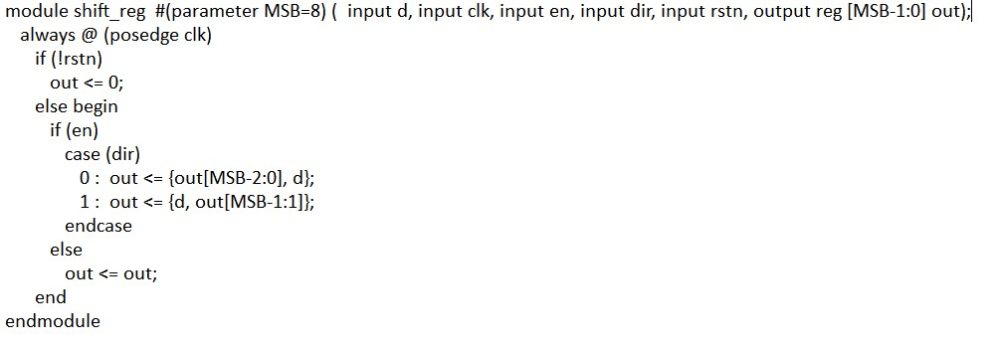

**Testbench file:**

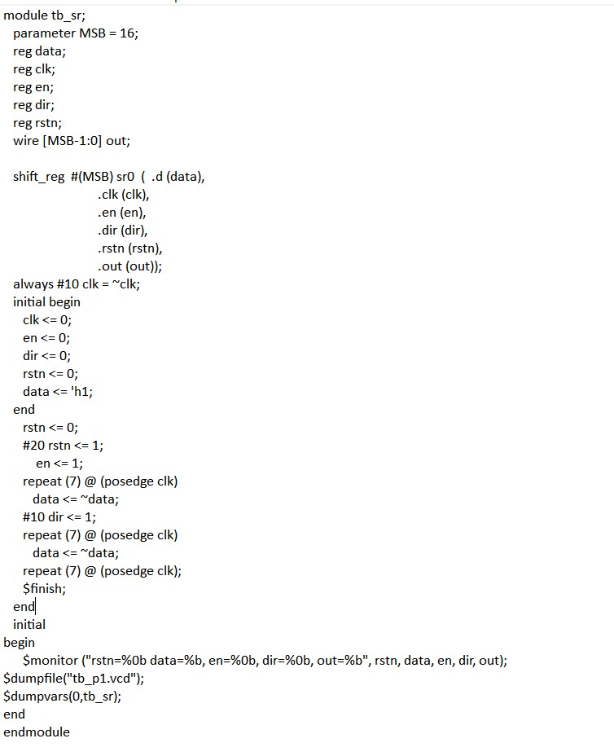

**CMD:**

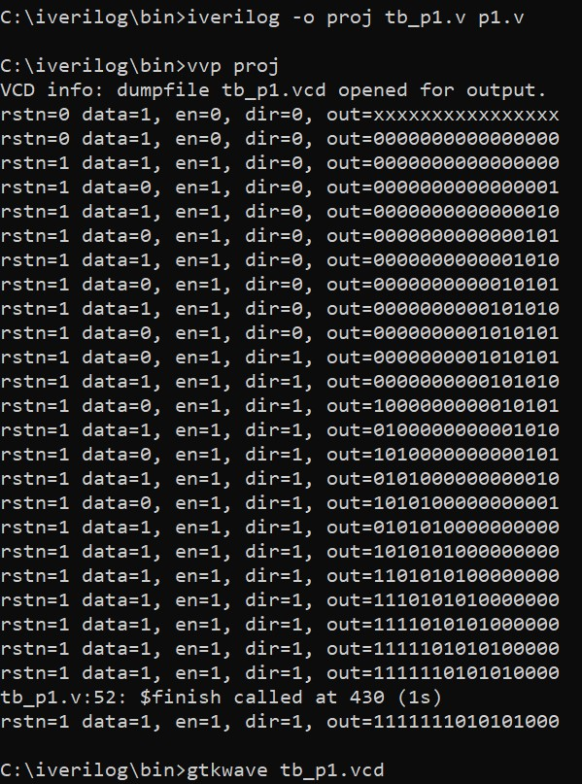

**GTKWAVE:**

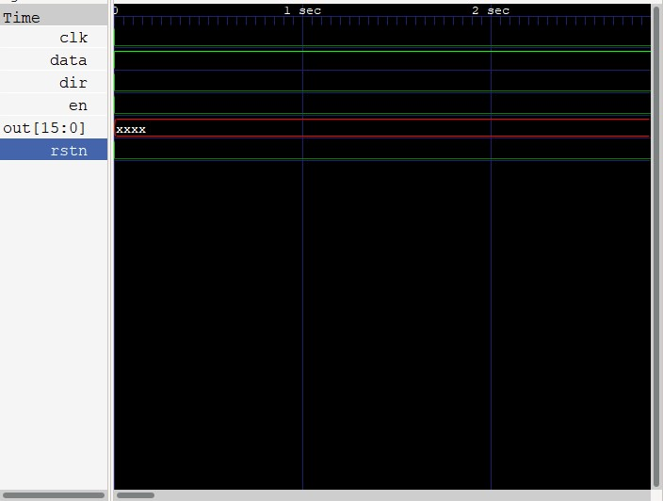

**Circuit Diagram:**

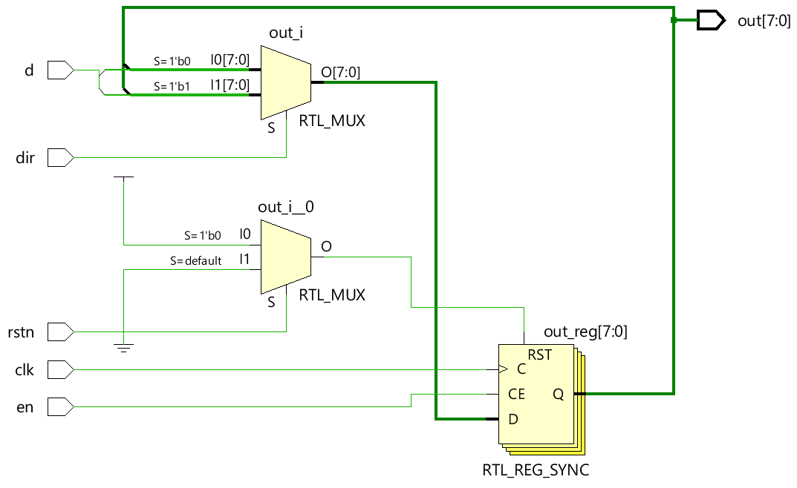

Signatures:

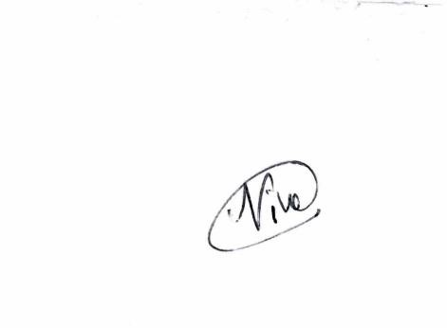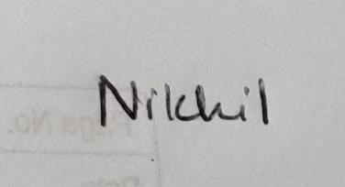 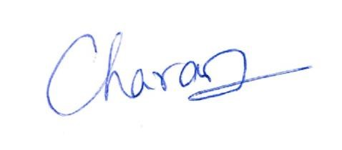

Nikhil Girish P Niveditha P Sai Charan

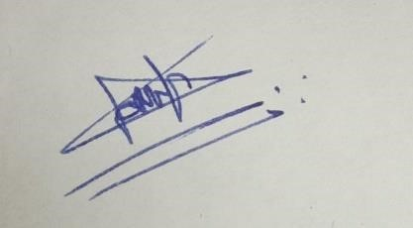

Onkar Suhasrao Pampattiwar